**Defects List**

**1.** **Bug title:**

Broken link to Buggy Home Page.

**Description**: Issue on getting back to home page by clicking ‘Buggy Rating’.

**Steps to Reproduce:**

1. Navigate to Buggy car Rating url ([buggyCarsRating](https://buggy.justtestit.org/register))
2. Click ‘Popular Make’.
3. Click ‘Buggy Rating’ on top left of the page.

**Expected Result:**

User should navigate to home page of Buggy cars rating.

**Actual Result:**

Clicking the link is not working.

Rank sort function is faulty. Rank goes from 1, 10, 11

**Priority**: High

**Environment:** QA

**Team:** XX

**Screenshot:**

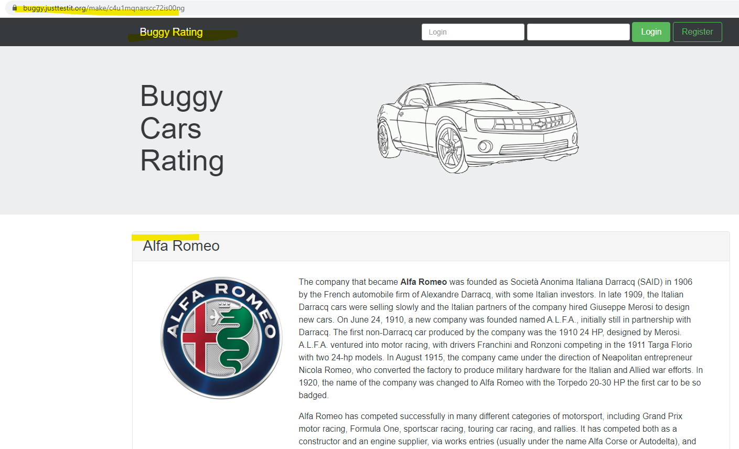

**2.Bug title:**

Rank filter does not working properly.

**Description** : Issue on sorting order by Rank.

**Steps to Reproduce:**

1. Navigate to Buggy car Rating url ([buggyCarsRating](https://buggy.justtestit.org/register))
2. Click ‘Overall Rating’.
3. Click ‘Rank’column.

**Expected Result:**

Rank should arrange entries from either descending to ascending or ascending to descending.

**Actual Result:**

Rank sort function is faulty. Rank goes from 1, 10, 11

**Priority**: High

**Severity**: Low

**Environment:** QA

**Team:** XX

***S*creenshot:**

**3.Bug title:**

Page navigation link is not working in Overall Rating page.

**Description**: Issue on going next page to see ‘List of registered car’.

**Steps to Reproduce:**

1. Navigate to Buggy car Rating url ([buggyCarsRating](https://buggy.justtestit.org/register)).
2. Click ‘Overall Rating’.
3. Enter the page number in the box of page navigation.[eg:3]
4. Click ‘Next’ arrow.

**Expected Result:**

Clicking the Next link goes to next page of current one.

**Actual Result:**

It goes random page number that’s not existing.

**Priority**: High

**Severity**: Low

**Environment:** QA

**Team:** XX

***S*creenshot:**

4. **Bug title:**

Author name is not displaying after Vote.

**Description** : Issue on displaying voting author name in the table.

**Steps to Reproduce:**

1. Navigate to Buggy car Rating url ([buggyCarsRating](https://buggy.justtestit.org/register))
2. Click ‘Popular Make’.
3. Click ‘View more’.
4. Click ‘Vote’ button with comments added.
5. Check the table for ‘Author’ name.

**Expected Result:**

Author of vote person name should be display in the table.

**Actual Result:**

There is no name in the ‘Author’ column.

**Priority**: High

**Severity**: Low

**Environment:** QA

**Team:** XX

**Screenshot:**

